Subprograms and Languages

# Elementary

Syntax is a structure of statements in a programming language. The syntax of a computer language is the set of rules that defines the combinations of symbols that are considered to be a correctly structured document or fragment in that language. This applies both to programming languages, where the document represents source code, and markup languages, where the document represents data. The syntax of a language defines its surface form. Text-based computer languages are based on sequences of characters, while visual programming languages are based on the spatial layout and connections between symbols (which may be textual or graphical). Documents that are syntactically invalid are said to have a syntax error.

No, the syntax of programming languages can differ between programming languages. Such as in Python the way variable are declared is different from Objective-C or Action Script 3. Eg: (Python) x = 1; (Objective-C) int x = 1; or (Action Script 3) var x:int = 1;.

5 Programming Languages are:

1. Pizza
2. Lilypond
3. Squirrel
4. Python
5. Dog

# Basic

Object code: Object code is a sequence of statements or instructions in a computer language, usually a machine code language (i.e 1s and 0s) or an intermediate language such as RTL.

Compiler: A compiler is a computer program (or set of programs) that transforms source code written in a programming language (the source language) into another computer language. The most common reason for wanting to transform source code is to create an executable program.

Interpreter: In computer science, an interpreter is a computer program that directly executes, i.e. performs, instructions written in a programming or scripting language.

# Sound

Subprogram: In computer programming, a subprogram is a sequence of program instructions that perform a specific task, packaged as a unit. This unit can be used in programs wherever that particular task should be performed. Subprograms may be defined within programs, or separately in libraries that can be used by multiple programs. In different programming languages a subprogram may be called a **procedure**, **function**, **routine**, **method**, or a **subroutine**.

Subprograms are used in programs to make the program more efficient and the to shorten the time taken to write a program. Instead of rewriting the same code every time it is needed in a program, it would be faster and easier to make that code a subprogram and *call* it whenever it is needed.

The shape for a subprogram in a flowchart is a double lined rectangle (below).

# Thorough

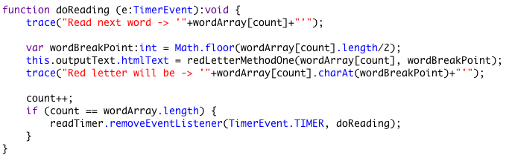Screenshot of subprogram in flash:

Parameter: numerical or other measurable factor forming one of a set that defines a system or sets the conditions of its operation.



Parameter: e is a Timer Event.

# Extensive

Code for multiplying 2 random numbers between 1- 100.

var a:int = Math.floor(Math.random()*100+1);

var b:int = Math.floor(Math.random()*100+1);

multiplyNumbers(a, b);

function multiplyNumbers(value1:int, value2:int):int {

var product:int = value1*value2;

trace(value1+" * "+value2+" = "+product);

return product;

}